“Multi-threaded Log Analysis System”
A Project Report Submitted in the partial fulfillment of the requirements for the award of the degree of
BACHELOR OF TECHNOLOGY
In
DEPARTMENT OF COMPUTER SCIENCE ENGINEERING
By
SHAIK JUNEETH | 2520030435
V ASHISH REDDY | 2520030415
D VENKATA MAHITH | 2520030497

Operating Systems and Systems Programming (25CS2104E)
Section 4 – Team 18
Under the Esteemed Guidance of
Ms. Soumya Enukonda
Assistant Professor
Department of Computer Science and Engineering



K L (Deemed to be) University
DEPARTMENT OF COMPUTER SCIENCE ENGINEERING
&
DEPARTMENT OF COMPUTER SCIENCE AND INFORMATION TECHNOLOGY
Declaration
The Project Report entitled “Multi-threaded Log Analysis System” is a record of Bonafide work of SHAIK JUNEETH - 2520030435, V ASHISH REDDY - 2520030415, D VENKATA MAHITH - 2520030497 submitted in partial fulfillment for the award of B. Tech in Computer Science and Engineering (or) Computer Science and Information Technology to the K L University. The results embodied in this report have not been copied from any other departments/University/Institute.

SHAIK JUNEETH | 2520030435
V ASHISH REDDY | 2520030415
D VENKATA MAHITH | 2520030497

K L (Deemed to be) University
DEPARTMENT OF COMPUTER SCIENCE ENGINEERING
&
DEPARTMENT OF COMPUTER SCIENCE AND INFORMATION TECHNOLOGY
CERTIFICATE
This is to certify that the project based report entitled “Multi-threaded Log Analysis System” is a bonafide work done and submitted by SHAIK JUNEETH - 2520030435, V ASHISH REDDY - 2520030415, D VENKATA MAHITH - 2520030497 in partial fulfillment of the requirements for the award of the degree of BACHELOR OF TECHNOLOGY in Department of Computer Science Engineering, K L (Deemed to be University), during the academic year 2026-2027.
Signature of the Guide
Signature of the Course Coordinator Signature of the HOD

ACKNOWLEDGEMENT
The success of this project would not have been possible without the timely help and guidance rendered by many people. We wish to express our sincere thanks to all those who have assisted us in one way or the other in the completion of our project.
Our greatest appreciation goes to our Course Coordinator Dr. K. Anusha and our guide Ms. Soumya Enukonda, Assistant Professor, Department of Computer Science and Engineering, whose tremendous support, encouragement and guidance cannot be expressed in words.
We express our gratitude to Dr. P. Venkateshwara Rao (CSE), Head of the Department of Computer Science and Engineering, for providing us with adequate facilities, ways and means by which we were able to complete this project-based lab.
We thank all the members of the teaching and non-teaching staff who have assisted us directly or indirectly in the successful completion of this project. Finally, we sincerely thank our parents, friends and classmates for their kind help and cooperation during our work.

SHAIK JUNEETH | 2520030435
V ASHISH REDDY | 2520030415
D VENKATA MAHITH | 2520030497
Abstract
Modern servers produce log files with millions of lines, and checking them with a single thread is slow and leaves most of a multi-core processor idle. This project, “Multi-threaded Log Analysis System,” analyses a large log file with several threads at the same time. The file is divided into chunks; worker threads take chunks from a shared task queue, classify every line as CRITICAL, ERROR, WARN or INFO, and search it for six kinds of suspicious events (failed logins, invalid users, SQL injection, path traversal, port scans and malware signatures).
The solution is written in C with POSIX threads (pthreads) and tested on Ubuntu using GCC. Each thread keeps private counters, so the line-scanning work needs no lock; the only shared data are the queue index and the global result, which are protected by two separate mutexes. A sample-log generator in Python and a browser dashboard built on Web Workers complete the system. In the tests, a log of 1,000,000 lines (54.8 MB) gave identical results with 1, 2, 4 and 8 threads, the counts matched the output of grep exactly, and ThreadSanitizer reported no data race. The test machine had a single CPU core, so the run time stayed at about 0.45 s for every thread count; the report explains why and how to measure the speed-up on a multi-core computer.
Index
S. No. | Chapter | Topics / Subtopics | Page No.
 | Acknowledgement |  | i
 | Abstract |  | ii
1 | Introduction |  | 1–3
 |  | 1.1 Background of the Project | 1
 |  | 1.2 Problem Statement | 1
 |  | 1.3 Scope of the Project | 1
 |  | 1.4 Objectives of the Project | 2
 |  | 1.5 Importance of the Application | 2
 |  | 1.6 Target Users / Audience | 2
 |  | 1.7 Team Responsibilities | 3
2 | OS Concepts and Background Study |  | 4–6
 |  | 2.1 Operating System Concepts Related to the Project | 4
 |  | 2.2 Existing Methods / Algorithms | 5
 |  | 2.3 Proposed Approach | 6
 |  | 2.4 Advantages of the Proposed Approach | 6
3 | System Requirements |  | 7–8
 |  | 3.1 Hardware Requirements | 7
 |  | 3.2 Software Requirements | 7
 |  | 3.3 Operating System Environment – Ubuntu / WSL | 7
 |  | 3.4 Development Tools and Compilers | 8
4 | Technology and Tools Used |  | 9–11
 |  | 4.1 C / C++ Programming | 9
 |  | 4.2 GCC Compiler | 9
 |  | 4.3 Linux System Calls | 9
 |  | 4.4 POSIX Threads / Synchronization | 10
 |  | 4.5 Linux Commands and Utilities | 10
 |  | 4.6 Other Tools / Libraries Used | 10
5 | System Architecture and Design |  | 12–16
 |  | 5.1 Overall System Architecture | 12
 |  | 5.2 System Workflow | 12
 |  | 5.3 Flowchart / Data Flow | 13
 |  | 5.4 Module Description | 14
 |  | 5.5 Input and Output Design | 15
6 | Implementation |  | 17–25
 |  | 6.1 Module-wise Implementation | 17
 |  | 6.2 Algorithm / Pseudocode | 17
 |  | 6.3 Core C / C++ Implementation | 18
 |  | 6.4 Linux System Calls / APIs Used | 22
 |  | 6.5 Process / Thread Implementation | 22
 |  | 6.6 IPC / Synchronization Implementation | 23
 |  | 6.7 Memory Management Implementation | 23
 |  | 6.8 Optional User Interface Implementation | 24
7 | Execution and Demonstration |  | 26–33
 |  | 7.1 Compilation in Ubuntu | 26
 |  | 7.2 Execution Commands | 26
 |  | 7.3 Sample Inputs and Outputs | 26
 |  | 7.4 Screenshots of Execution | 29
 |  | 7.5 Demonstration of OS Concepts | 32
8 | Conclusion |  | 34–35
 |  | 8.1 Summary of the Project | 34
 |  | 8.2 Objectives Achieved | 34
 |  | 8.3 Results Achieved | 35
 |  | 8.4 Skills and Learning Outcomes | 35
9 | References |  | 36
 |  | 9.1 Books | 36
 |  | 9.2 Research Papers | 36
 |  | 9.3 Linux / GNU Documentation | 36
 |  | 9.4 Online Resources | 36

CHAPTER 1: INTRODUCTION

1.1 Background of the Project
Every running server, web application and operating system writes a log: a text file in which each line records one event with a time stamp, a severity level, the address of the client and a short message. On a busy system these files grow by thousands of lines every minute. A log of one day can easily contain millions of lines, and the lines that matter (a database that is down, a user who tried a wrong password fifty times, a request that contains an SQL injection) are hidden among a very large number of ordinary “INFO” lines.
A traditional program reads such a file from the first line to the last with a single thread, so the time needed grows in proportion to the size of the file, and on a computer with several cores only one core does the work. Operating systems offer threads to solve this problem. Threads of one process share the same memory, so a large job can be divided between them, but the shared data then have to be protected with synchronization primitives such as mutexes, otherwise the threads overwrite each other’s updates and the final numbers are wrong.
This project builds a Multi-threaded Log Analysis System. The log file is divided into chunks, several worker threads take chunks from a shared queue and analyse them in parallel, and the partial results are merged into one summary under mutex protection. The core is written in C with POSIX threads on Linux; a Python generator produces test logs and a browser dashboard based on Web Workers shows the same design visually.

1.2 Problem Statement
Server and application logs grow to millions of lines, and scanning them with one thread is slow. Searching them by hand with tools such as cat, grep or a text editor finds one pattern at a time and gives no combined picture of how many errors, warnings and suspicious events there are. If a programmer simply starts several threads that all update the same counters without locks, a race condition occurs and the totals are wrong.
The problem addressed by this project is: how can a large log file be analysed quickly by several threads, so that errors, warnings and suspicious events are found and counted, and so that the final result is exactly the same as that of a single-threaded run? The project answers this by dividing the file into chunks, giving each thread its own private counters and protecting the few shared data with mutexes.

1.3 Scope of the Project
Within the scope of the project:
- Reading a large log file and dividing it into chunks of a configurable number of lines.
- Creating a configurable number of worker threads with pthread_create() and waiting for them with pthread_join().
- Distributing the chunks dynamically through a shared task queue whose index is protected by a mutex.
- Classifying every line as CRITICAL, ERROR, WARN or INFO, and detecting six kinds of suspicious events by keyword: failed login, invalid user, SQL injection, path traversal, port scan and malware.
- Merging the private results of the threads into a global summary under a second mutex and printing a report with the elapsed time.
- A sample-log generator (Python) and a browser dashboard (Web Workers) that mirror the design.
- Compilation, execution and testing on Ubuntu Linux (native or WSL2) using GCC.
Outside the scope of the project:
- Real-time monitoring of a growing log file (for example tail -f) and sending alerts.
- Distributed analysis on several computers; all threads run in one process on one machine.
- User-defined rules and regular expressions; the six detection keywords are fixed in the source code.
- Log files that are larger than the available main memory, because the file is read completely into memory.

1.4 Objectives of the Project
The objectives of the project are:
- To divide a large log file into chunks that are processed concurrently by multiple threads.
- To identify and count the ERROR and WARNING entries (and CRITICAL and INFO entries) in every chunk.
- To detect suspicious events such as failed logins and unauthorized access using keyword patterns.
- To merge the results of the threads safely with mutexes and to report a final summary together with the time taken.
- To understand thread creation, work division, race conditions and synchronization in a practical Linux program.

1.5 Importance of the Application
Log analysis is one of the first things a system administrator, a security analyst or a developer does when something goes wrong. The earlier an error or an attack is found, the smaller the damage. Parallel processing makes this faster, because the time of the scanning phase can be divided by the number of cores that are really available, until the serial parts of the program or the disk become the limit (Amdahl’s law).
The same pattern is used in many real systems: search tools that scan large files in parallel, web servers that handle each request in a worker thread, build tools that compile many files at once and databases that scan a table with several threads. Understanding it gives a solid foundation for concurrency, synchronization and parallel programming in general.

1.6 Target Users / Audience
- Students of Operating Systems and Systems Programming who want to see threads, mutexes and race conditions in a practical, working example.
- Instructors who need a small, clear program to demonstrate work division and synchronization with pthreads in a lecture or lab.
- System administrators and security analysts who want a quick summary of the severity levels and suspicious events in a large log.

1.7 Team Responsibilities
Table 1.1 shows the individual responsibilities of the team members.
Table 1.1: Team members and responsibilities
Name of Candidate | Roll No. | Individual Responsibility
SHAIK JUNEETH | 2520030435 | Design and implementation of the multi-threaded log analyzer
V ASHISH REDDY | 2520030415 | Linux execution, multi-thread testing and GitHub management
D VENKATA MAHITH | 2520030497 | Documentation, output verification and presentation

CHAPTER 2: OS CONCEPTS AND BACKGROUND STUDY

2.1 Operating System Concepts Related to the Project
The project is built on the following core Operating System concepts.

Process and thread
A process is a program in execution with its own virtual address space. A thread is a unit of execution inside a process. All threads of a process share the code, the global variables and the heap, but each thread has its own stack, its own registers and its own program counter. In Linux a thread is created with pthread_create(), which calls clone() internally, and the kernel schedules every thread independently, so threads can run on different cores at the same time. Because memory is shared, creating a thread is cheaper than creating a process and passing data between threads needs no pipes or messages; the price is that the programmer must control the access to shared data.

POSIX threads (pthreads)
POSIX threads is the standard thread library of Linux. The calls used in this project are pthread_create() to start a thread that runs a given function, pthread_join() to wait until a thread has finished, and pthread_mutex_lock() and pthread_mutex_unlock() to enter and leave a critical section. Programs that use it are compiled with the -pthread option.

Race condition and critical section
A race condition occurs when the result of a program depends on the order in which threads access shared data. For example, the statement global.err += local.err is really three steps (read, add, write). If two threads execute it at the same time, both may read the same old value and one of the updates is lost, so the final count is too small. A critical section is the part of the code that accesses shared data; only one thread may be inside it at any moment.

Mutex (mutual exclusion lock)
A mutex guarantees mutual exclusion. A thread that calls pthread_mutex_lock() on a free mutex becomes its owner; any other thread that calls it on the same mutex is blocked by the kernel until the owner calls pthread_mutex_unlock(). The cost of a mutex is waiting time, so the critical sections should be as short as possible and should be entered as rarely as possible. This project therefore uses two mutexes, each protecting a very short critical section, and no lock at all while a chunk is being scanned.

Work queue (producer–consumer) and load balancing
If the file were divided into exactly one block per thread, a thread with an “expensive” block (many suspicious lines) would finish last while the others wait. The project divides the file into many more chunks than threads and puts them in a shared queue; a thread that has finished a chunk takes the next free one. Fast threads automatically process more chunks, which balances the load dynamically. The queue is only an index (next_chunk) protected by a mutex.

Data parallelism, speed-up and Amdahl’s law
Analysing different lines is an example of data parallelism: the same operation is applied to different pieces of data, and the pieces do not depend on each other. If a fraction p of the work can be done in parallel on n cores, the best possible speed-up is 1 / ((1 − p) + p / n) (Amdahl’s law). In this program the serial parts are reading the file, splitting it into chunks and printing the report; the scanning of the lines is the parallel part. The speed-up can never be greater than the number of cores that are really available.

File input and memory
The file is read once with fread() into one large buffer obtained with malloc(). The kernel copies the data from the page cache (or the disk) into this buffer. After that, the buffer is only read, never written, by the worker threads, so reading it needs no synchronization.
Table 2.1: Single-threaded, naive multi-threaded and proposed analysis
Feature | Single thread | Threads without locks | Proposed (chunks + mutexes)
Cores used | One | All | All
Time for a large file | Grows with file size | Short | Short (limited by cores and serial part)
Correctness of counters | Correct | Wrong (race condition) | Correct
Load balancing | Not needed | Usually static | Dynamic, through the task queue
Synchronization cost | None | None | Two short critical sections
Complexity | Simple | Simple but unsafe | Moderate

2.2 Existing Methods / Algorithms
Table 2.2 lists the usual ways of checking a log file and shows what the proposed system adds.
Table 2.2: Methods for analysing large log files
Method | Description | Remarks
Manual reading (editor, cat) | A person scrolls through the file | Impossible for millions of lines; important events are easily missed
grep and shell pipelines | Searches one pattern at a time; counts with grep -c | Fast for a single pattern, but every question needs a new command and there is no combined summary
Single-threaded script | Reads the file line by line and counts events | Simple and correct, but uses one core only; time grows with the file size
Multi-process (split + several processes) | The file is split into pieces and several processes analyse them | Uses all cores, but results must be passed between processes (pipes, files) and merged afterwards
Threads without locks | Several threads update the same counters | Fast but wrong: lost updates give incorrect totals (race condition)
Static partition (one block per thread) | The file is divided into T equal blocks | Simple; a thread with a slow block makes the others wait
Chunk queue with private counters and mutexes | Many chunks in a shared queue; private counters are merged under a mutex | Fast, correct and load-balanced; the method used in this project

2.3 Proposed Approach
The proposed approach is a small system of three modules that together analyse, generate and display log data:
- Module 1 – log_analyzer.c: the multi-threaded analyzer in C. The main thread reads the file and splits it into chunks; worker threads take chunks from the shared queue, classify the lines into private counters and finally merge them into the global result.
- Module 2 – gen_logs.py: a Python program that creates a sample log file of any number of lines, with a known share of errors, warnings and suspicious events, so that the analyzer can be tested with large inputs.
- Module 3 – web/index.html: a dashboard that runs the same design in a browser with Web Workers. It shows the activity of every thread, charts, the most suspicious IP addresses and a filterable list of events.
Every program prints clear messages and checks the result of the important calls (opening the file, reading it, wrong arguments), so that errors are reported instead of ignored.

2.4 Advantages of the Proposed Approach
- Speed on multi-core machines: the scanning phase is divided between the threads, so its time falls as more cores are used.
- Correctness: every thread counts into private variables; the merged result is the same for any number of threads, which was checked in the tests.
- Low lock contention: a lock is taken once per chunk (to take the next chunk) and once per thread (to merge), not once per line.
- Dynamic load balancing: the chunk queue gives more work to the faster threads.
- Simplicity and portability: about 80 lines of standard C and POSIX threads; no external libraries are needed.
- Visibility: the dashboard makes the work of the threads visible and the generator makes the tests repeatable.

CHAPTER 3: SYSTEM REQUIREMENTS

3.1 Hardware Requirements
The programs are small. The analyzer holds the whole log file in memory, so the memory needed is about the size of the log file plus a small table of chunks; the test log of 1,000,000 lines needs about 52 MiB. To see a speed-up, a processor with several cores is required. The minimum and recommended configurations are given in Table 3.1.
Table 3.1: Hardware requirements
Component | Minimum | Recommended
Processor | Dual-core x86-64, 1.6 GHz | Quad-core or more, 2.4 GHz or higher (more cores give more speed-up)
RAM | 2 GB | 4 GB or more (log files are read completely into memory)
Storage | 5 GB free space | 10 GB free space (for large log files)
Display | 1366 × 768 | 1920 × 1080 (for the dashboard)
Network | Needed only for installing packages and using GitHub | Broadband connection

3.2 Software Requirements
Table 3.2: Software requirements
Software | Details
Operating system | Ubuntu 22.04 LTS or 24.04 LTS (native, virtual machine, or Ubuntu on WSL2). The output in this report was produced on Ubuntu 24.04.4 LTS.
Linux kernel | Any 4.x or newer kernel; a 6.x kernel was used
Compiler | GCC 11 or later (GCC 13.3.0 was used for the results in this report)
Threading library | POSIX Threads (pthreads), part of the GNU C library; compile with -pthread
Python | Python 3.8 or later for gen_logs.py
Web browser | Chrome, Edge or Firefox (for the dashboard; no installation needed)
Editor / IDE | VS Code, Vim or Nano
Debugger / race detector | GDB and ThreadSanitizer (-fsanitize=thread, included in GCC)
Version control | Git and a GitHub account

3.3 Operating System Environment – Ubuntu / WSL
The project targets Ubuntu Linux because POSIX threads, clock_gettime() and the GNU extension strcasestr() are available there. Students who use Windows can use Windows Subsystem for Linux 2 (WSL2), which runs a real Linux kernel inside Windows. To install Ubuntu on WSL, open PowerShell as Administrator and run:
wsl --install -d Ubuntu

After restarting, create a Linux user name and password when prompted, then update the package list:
sudo apt update && sudo apt upgrade -y

Project files should be kept on the Linux file system (for example under /home) rather than on Windows-mounted drives such as /mnt/c, because file access on those drives is much slower. WSL2 gives access to all processor cores of the computer, so the speed-up can be measured there.

3.4 Development Tools and Compilers
All required tools can be installed with a single command:
sudo apt install build-essential gdb git python3 -y
gcc --version
nproc # number of CPU cores available to the programs

The build-essential package installs GCC, the C library headers and make. nproc shows how many cores the system offers, which is the upper limit of the speed-up.

CHAPTER 4: TECHNOLOGY AND TOOLS USED

4.1 C / C++ Programming
C is the natural language for systems programming on Linux. It gives direct control over memory, which this project needs: the whole log file is held in one buffer, the newline characters are replaced by string terminators, and the threads walk through the buffer with plain pointers. The analyzer is written in C (GNU extensions enabled with _GNU_SOURCE, because the case-insensitive search strcasestr() is a GNU function).

4.2 GCC Compiler
GCC (GNU Compiler Collection) is used to compile the program. The following options were used:
- -Wall -Wextra – enable common and extra warnings so that mistakes are caught at compile time.
- -O2 – optimise the code; this matters for a program whose time is spent in a tight scanning loop.
- -pthread – compile and link with POSIX threads.
- -fsanitize=thread – build a test version with ThreadSanitizer, which detects data races at run time.
- -o name – set the name of the output executable.
Example: gcc -Wall -Wextra -O2 -pthread -o log_analyzer log_analyzer.c. The program compiles without any warning.

4.3 Linux System Calls
Table 4.1 lists the system calls and library functions used in the project. The pthread functions are provided by the C library; internally they use the kernel calls clone() and futex(). The file functions are buffered wrappers around open(), read() and lseek().
Table 4.1: System calls and library functions used
Function | Header | Prototype | Role in the project
pthread_create | pthread.h | int pthread_create(pthread_t *t, const pthread_attr_t *a, void *(*fn)(void *), void *arg) | Starts a worker thread
pthread_join | pthread.h | int pthread_join(pthread_t t, void **ret) | Main thread waits for a worker
pthread_mutex_lock / unlock | pthread.h | int pthread_mutex_lock(pthread_mutex_t *m) | Enter / leave a critical section
fopen, fseek, ftell, fread, fclose | stdio.h | size_t fread(void *p, size_t sz, size_t n, FILE *f) | Open the log and read it into memory
malloc | stdlib.h | void *malloc(size_t n) | Buffer, chunk table and thread array
clock_gettime | time.h | int clock_gettime(clockid_t id, struct timespec *ts) | Measures the analysis time
strstr, strcasestr | string.h | char *strcasestr(const char *h, const char *n) | Finds the level tags and suspicious keywords
strlen | string.h | size_t strlen(const char *s) | Moves to the next line inside a chunk

4.4 POSIX Threads / Synchronization
The project is thread-based. Two mutexes of type pthread_mutex_t, both initialised statically with PTHREAD_MUTEX_INITIALIZER, protect the shared data:
- queue_lock protects the variable next_chunk, the index of the next chunk that has not yet been taken (critical section 1).
- result_lock protects the global Stats structure into which every thread merges its private counters before it ends (critical section 2).
The main thread uses pthread_join() as a barrier: it continues with the report only after all worker threads have ended. No condition variables, semaphores or atomic operations are needed, because the chunk table is completely filled before the threads are created and is only read afterwards.

4.5 Linux Commands and Utilities
Table 4.2: Linux commands and utilities used
Command | Purpose
nproc, lscpu | Show the number of CPU cores
gcc, gdb | Compile and debug the programs
grep -c, wc -l | Independent counting of matching lines and of all lines, used to verify the analyzer
head, ls -l | Look at the first lines and the size of the log file
top -H | Shows every thread of a process separately while the program runs
uname -r | Shows the kernel version

4.6 Other Tools / Libraries Used
- Standard C library: stdio.h, stdlib.h, string.h, strings.h and time.h for input and output, memory, strings and time.
- Python 3: the log generator gen_logs.py, which uses only the standard modules random, sys and datetime.
- HTML, CSS and JavaScript (Web Workers): the browser dashboard; Web Workers are real operating-system threads of the browser.
- Git and GitHub: version control and sharing of the source code.
- VS Code: source-code editing and debugging.
- Python (matplotlib and Pillow) and a headless browser: used only to draw the diagrams in Chapter 5 and to render the captured terminal output and dashboard screenshots in Chapters 6 and 7; they are not part of the project programs.

CHAPTER 5: SYSTEM ARCHITECTURE AND DESIGN

5.1 Overall System Architecture
Figure 5.1 shows the overall architecture. The main thread reads the log file into memory and divides it into chunks of a fixed number of lines; the chunks are recorded in a table. A shared task queue, which is just the index next_chunk protected by queue_lock, hands the chunks to the worker threads. Each worker scans its chunks and counts into its own private Stats structure, so no lock is held while lines are analysed. When the queue is empty, each worker merges its private counters into the global Stats under result_lock. The main thread joins all workers and prints the report.
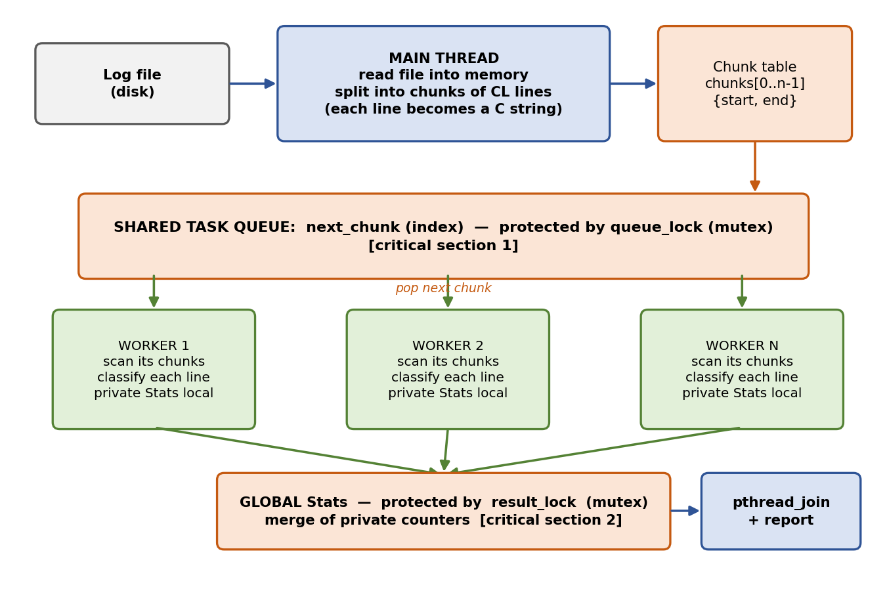
Figure 5.1: Overall system architecture

5.2 System Workflow
Workflow of the analyzer (log_analyzer)
- The user runs the analyzer with a log file, the number of threads T and (optionally) the chunk size CL.
- The main thread reads the whole file into one buffer and replaces every newline by a string terminator, so that each line becomes a C string.
- It records the start and end of every CL lines in the chunk table.
- The main thread starts the timer and creates T worker threads with pthread_create().
- Each worker repeatedly takes the next chunk index under queue_lock and scans the lines of that chunk; every line is classified by severity and checked against the six suspicious patterns, and the counts go to the worker’s private Stats.
- When no chunk is left, the worker adds its private counters to the global Stats under result_lock, prints how many chunks and lines it processed, and ends.
- The main thread waits for all workers with pthread_join(), stops the timer and prints the final report.
Workflow of the sample-log generator (gen_logs.py)
- The program reads the number of lines and the output file name from the command line.
- For each line it draws a random number to choose the level (about 1.2 % suspicious ERROR lines, 0.8 % CRITICAL, 3 % ERROR, 8 % WARN, the rest INFO), picks a message and an IP address and writes the line with a time stamp.
Workflow of the dashboard (web/index.html)
- The user chooses to generate a sample log or to upload a file, the number of worker threads and the chunk size.
- The page splits the text into chunks and starts the Web Workers.
- Each worker analyses a chunk and sends the result back; the main page merges the results and gives the worker the next chunk.
- The page shows the thread activity, the key figures, the events per hour, the suspicious patterns, the most suspicious IP addresses and a filterable list of events.

5.3 Flowchart / Data Flow
Figure 5.2 shows the flow of the analyzer. The left side is the main thread, the right side is the code that every worker thread executes. The orange boxes are the two critical sections. The dashed arrows show thread creation and the return of the threads to the join. Figure 5.3 shows schematically how three threads work in time: most of the time is spent scanning chunks without any lock, and the time a thread holds a mutex is very short, so the threads rarely wait for each other.
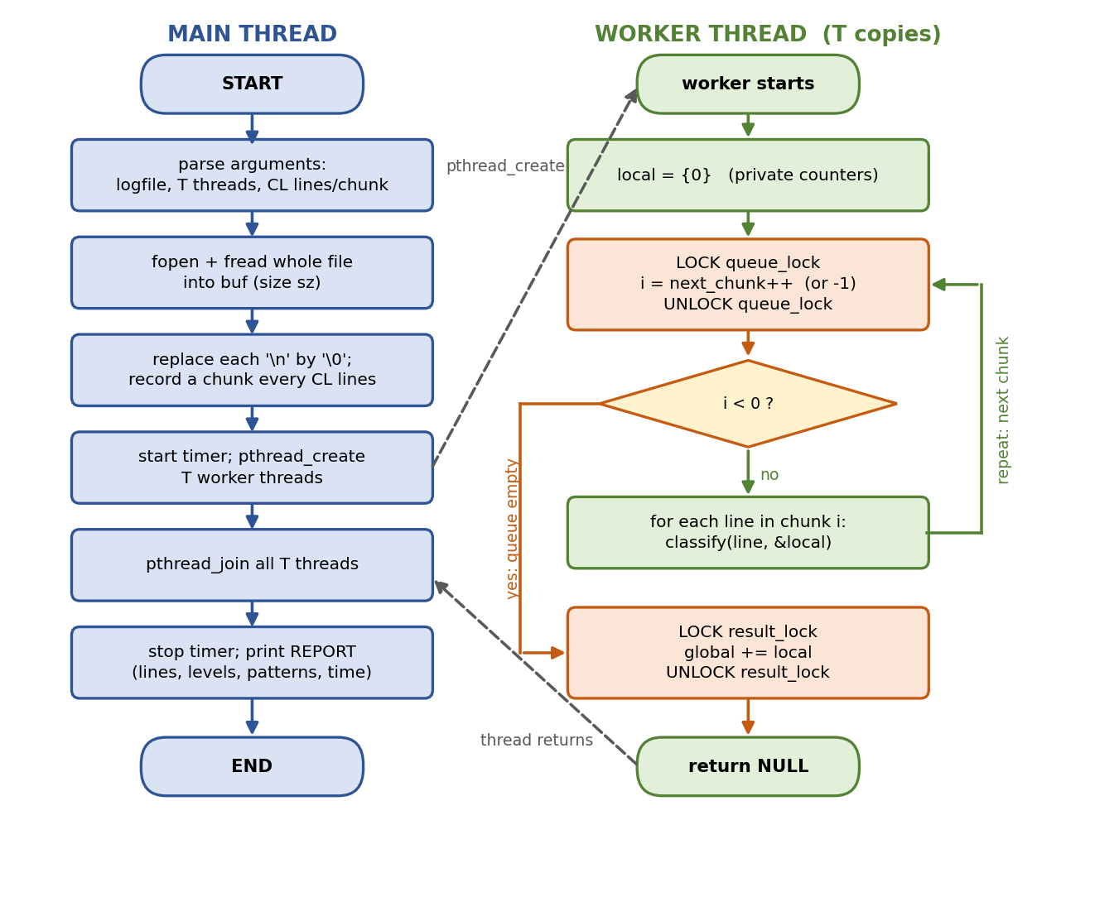
Figure 5.2: Flowchart of the multi-threaded log analyzer
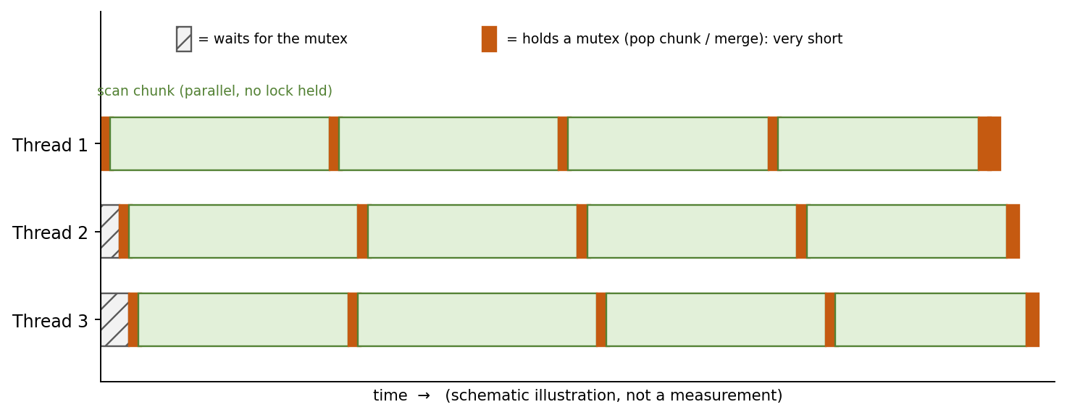
Figure 5.3: Threads, chunks and mutex use over time (schematic)

5.4 Module Description
Table 5.1: Modules of the project
Module | File | Description | Main calls
M1 – Analyzer | c/log_analyzer.c | Reads and splits the file, creates the worker threads, classifies the lines, merges the results and prints the report | pthread_create, pthread_join, pthread_mutex_lock, fread
M2 – Generator | c/gen_logs.py | Writes a sample log with a chosen number of lines and a known mix of levels and suspicious events | random, datetime
M3 – Dashboard | web/index.html | Runs the same design in the browser with Web Workers; adds charts, an IP table and an event explorer | Worker, postMessage
M4 – Error handling | log_analyzer.c | Checks the result of fopen() and fread(); prints a usage message if the file name is missing; replaces invalid thread or chunk values | perror, fprintf

The detection rules of the C analyzer are shown in Table 5.2. The severity of a line is taken from the tag in square brackets; the first matching tag in the order CRITICAL, ERROR, WARN decides, and a line without any of these tags is counted as INFO. The suspicious patterns are searched in every line independently of its level, ignoring upper and lower case. A line counts once as “suspicious” even if it matches several patterns. (The dashboard uses a slightly wider rule set, for example it also recognises “privilege escalation”, and in addition counts failed logins per IP address.)
Table 5.2: Detection rules of the C analyzer
Class | Search text | Case-insensitive? | Example line
CRITICAL | [CRITICAL] | No | … [CRITICAL] … Database timeout
ERROR | [ERROR] | No | … [ERROR] … Connection refused
WARN | [WARN] | No | … [WARN] … Slow query detected
INFO | (none of the above) | – | … [INFO] … Cache refreshed
Failed login | failed password | Yes | Failed password for root
Invalid user | invalid user | Yes | Invalid user admin
SQL injection | union select | Yes | GET /?id=1 UNION SELECT x
Path traversal | ../ | Yes | GET /../../etc/passwd
Port scan | port scan | Yes | Port scan detected
Malware | malware | Yes | Malware signature matched

5.5 Input and Output Design
Input design. The analyzer is started as ./log_analyzer <logfile> [threads=4] [chunk_lines=20000]. The log file is a text file with one event per line in the format YYYY-MM-DD HH:MM:SS [LEVEL] IP-address message. A thread count or chunk size smaller than 1 is replaced by 1 (threads) or 20000 (chunk size). If the file name is missing or the file cannot be opened, the program prints a message and stops with exit status 1. The generator is started as python3 gen_logs.py [lines=500000] [output=sample.log].
Output design. The analyzer first prints the file name, the number of threads and the number of chunks. Each worker then prints one line with the number of chunks and lines it processed, which shows the load distribution. The final report lists the total number of lines, the counts of CRITICAL, ERROR, WARN and INFO lines, the number of suspicious lines, the count of every suspicious pattern and the analysis time in seconds. The time covers the thread phase only; reading the file and splitting it into chunks are not included.

CHAPTER 6: IMPLEMENTATION

6.1 Module-wise Implementation
Module M1 – Analyzer (log_analyzer.c). The program defines two structures: Stats, which holds the counters (lines, critical, error, warn, info, suspicious and one counter for each of the six patterns), and Chunk, which holds the start and end pointer of a chunk. The function classify() analyses one line, worker() is the function every thread runs, and main() reads the file, builds the chunk table, creates and joins the threads and prints the report.
Module M2 – Generator (gen_logs.py). The program writes the requested number of lines. A random number selects the level: 1.2 % suspicious lines (level ERROR, one of the six suspicious messages and an address of the range 203.0.113.x), 0.8 % CRITICAL, 3 % ERROR, 8 % WARN and the rest INFO. The time stamps run through 36 hours.
Module M3 – Dashboard (index.html). analyze() is the function that runs in each Web Worker; it processes one chunk of text and returns the counters, the per-IP statistics, the events per hour and a sample of events. run() starts the workers, hands out the chunks and merges the results with mergeInto(). If the browser does not allow workers, the page falls back to a cooperative simulation and tells the user so.

6.2 Algorithm / Pseudocode
Algorithm 1 – Main thread
read logfile into buf (size sz); buf[sz] = '\0'
chunks = []; cs = start of buf; ln = 0
for each character p in buf:
if *p == '\n':
*p = '\0' // line becomes a C string
ln = ln + 1
if ln mod CL == 0: chunks.add(cs, p+1); cs = p+1
if cs < end of buf: chunks.add(cs, end) // last, shorter chunk
start timer
for i = 0 .. T-1: pthread_create(worker, i)
for i = 0 .. T-1: pthread_join(i)
stop timer; print report of global

Algorithm 2 – Worker thread
local = {0} // private counters
loop:
lock(queue_lock)
i = next_chunk; if i < number_of_chunks: next_chunk = next_chunk + 1
else i = -1
unlock(queue_lock)
if i < 0: break
for each line in chunks[i]: classify(line, local)
lock(result_lock)
global = global + local // add all counters
unlock(result_lock)
print chunks and lines processed by this thread

Algorithm 3 – Classification of one line
s.lines = s.lines + 1
if line contains "[CRITICAL]": s.crit++
else if contains "[ERROR]": s.err++
else if contains "[WARN]": s.warn++
else: s.info++
hit = false
for each of the six patterns k:
if line contains pattern k (ignoring case): s.pat[k]++; hit = true
if hit: s.susp++

Algorithm 4 – Dashboard engine (Web Workers)
split text into chunks; next = 0
create T workers
for each worker w:
feed(w): if next < number of chunks: send chunks[next++] to w
else terminate w
on message from w: mergeInto(global, result); feed(w)
when all chunks are done: render(global)

6.3 Core C / C++ Implementation
The complete source of the analyzer and of the generator is given below, followed by the main functions of the dashboard.

Program 1: log_analyzer.c
// Multi-threaded Log Analyzer (pthreads) - OSSP project
// Build: gcc -O2 -pthread -o log_analyzer log_analyzer.c
// Usage: ./log_analyzer <logfile> [threads=4] [chunk_lines=20000]
#define _GNU_SOURCE
#include <stdio.h>
#include <stdlib.h>
#include <string.h>
#include <strings.h>
#include <pthread.h>
#include <time.h>

typedef struct { long lines, crit, err, warn, info, susp, pat[6]; } Stats;
typedef struct { char *start, *end; } Chunk;

static const char *PAT_NAME[6] = {"Failed login", "Invalid user", "SQL injection",
"Path traversal", "Port scan", "Malware"};
static const char *PAT_KEY[6] = {"failed password", "invalid user", "union select",
"../", "port scan", "malware"};

static Chunk *chunks; static long nchunks, next_chunk = 0;
static Stats global; // shared result
static pthread_mutex_t queue_lock = PTHREAD_MUTEX_INITIALIZER;
static pthread_mutex_t result_lock = PTHREAD_MUTEX_INITIALIZER;

static void classify(const char *ln, Stats *s) {
s->lines++;
if (strstr(ln, "[CRITICAL]")) s->crit++;
else if (strstr(ln, "[ERROR]")) s->err++;
else if (strstr(ln, "[WARN]")) s->warn++;
else s->info++;
int hit = 0;
for (int i = 0; i < 6; i++)
if (strcasestr(ln, PAT_KEY[i])) { s->pat[i]++; hit = 1; }
if (hit) s->susp++;
}

static void *worker(void *arg) {
long id = (long)arg, done = 0;
Stats local = {0}; // private: no data races
for (;;) {
pthread_mutex_lock(&queue_lock); // critical section 1: task queue
long i = (next_chunk < nchunks) ? next_chunk++ : -1;
pthread_mutex_unlock(&queue_lock);
if (i < 0) break;
char *p = chunks[i].start, *end = chunks[i].end;
while (p < end) { classify(p, &local); p += strlen(p) + 1; }
done++;
}
pthread_mutex_lock(&result_lock); // critical section 2: merge
global.lines += local.lines; global.crit += local.crit; global.err += local.err;
global.warn += local.warn; global.info += local.info; global.susp += local.susp;
for (int i = 0; i < 6; i++) global.pat[i] += local.pat[i];
pthread_mutex_unlock(&result_lock);
printf(" thread %ld processed %ld chunks (%ld lines)\n", id + 1, done, local.lines);
return NULL;
}

int main(int argc, char **argv) {
if (argc < 2) { fprintf(stderr, "usage: %s <logfile> [threads] [chunk_lines]\n", argv[0]); return 1; }
int T = argc > 2 ? atoi(argv[2]) : 4; long CL = argc > 3 ? atol(argv[3]) : 20000;
if (T < 1) T = 1;
if (CL < 1) CL = 20000;
FILE *f = fopen(argv[1], "rb"); if (!f) { perror("open"); return 1; }
fseek(f, 0, SEEK_END); long sz = ftell(f); rewind(f);
char *buf = malloc(sz + 1); if (fread(buf, 1, sz, f) != (size_t)sz) { perror("read"); return 1; }
buf[sz] = '\0'; fclose(f);

// split into chunks of CL lines; turn '\n' into '\0' so each line is a C string
long cap = sz / CL + 2; chunks = malloc(cap * sizeof(Chunk));
char *p = buf, *cs = buf; long ln = 0;
for (; p < buf + sz; p++) if (*p == '\n') {
*p = '\0';
if (++ln % CL == 0) { chunks[nchunks++] = (Chunk){cs, p + 1}; cs = p + 1; }
}
if (cs < buf + sz) chunks[nchunks++] = (Chunk){cs, buf + sz + 1};

struct timespec a, b; clock_gettime(CLOCK_MONOTONIC, &a);
pthread_t *th = malloc(T * sizeof(pthread_t));
printf("Analyzing %s with %d thread(s), %ld chunks\n", argv[1], T, nchunks);
for (long i = 0; i < T; i++) pthread_create(&th[i], NULL, worker, (void *)i);
for (int i = 0; i < T; i++) pthread_join(th[i], NULL);
clock_gettime(CLOCK_MONOTONIC, &b);
double s = (b.tv_sec - a.tv_sec) + (b.tv_nsec - a.tv_nsec) / 1e9;

printf("\n=== REPORT ===\nLines: %ld\nCRITICAL: %ld ERROR: %ld WARN: %ld INFO: %ld\nSuspicious lines: %ld\n",
global.lines, global.crit, global.err, global.warn, global.info, global.susp);
for (int i = 0; i < 6; i++) printf(" %-15s %ld\n", PAT_NAME[i], global.pat[i]);
printf("Time: %.3fs\n", s);
return 0;
}

Program 2: gen_logs.py
#!/usr/bin/env python3
"""Generate a sample log file. Usage: python3 gen_logs.py [lines=500000] [out=sample.log]"""
import random, sys, datetime
n = int(sys.argv[1]) if len(sys.argv) > 1 else 500000
out = sys.argv[2] if len(sys.argv) > 2 else "sample.log"
info = ["User logged in", "Request served 200 OK", "Cache refreshed", "Backup completed"]
warn = ["Disk usage at 85%", "Slow query detected", "High memory usage"]
err = ["Database timeout", "Service unavailable 503", "Connection refused"]
sus = ["Failed password for root", "Invalid user admin", "GET /?id=1 UNION SELECT x",
"GET /../../etc/passwd", "Port scan detected", "Malware signature matched"]
t0 = datetime.datetime(2026, 10, 15)
with open(out, "w") as f:
for i in range(n):
ts = (t0 + datetime.timedelta(seconds=i * 129600 / n)).strftime("%Y-%m-%d %H:%M:%S")
p = random.random(); ip = "10.0.%d.%d" % (random.randint(0, 7), random.randint(10, 70))
if p < .012: lv, m, ip = "ERROR", random.choice(sus), "203.0.113.%d" % random.randint(1, 5)
elif p < .02: lv, m = "CRITICAL", random.choice(err)
elif p < .05: lv, m = "ERROR", random.choice(err)
elif p < .13: lv, m = "WARN", random.choice(warn)
else: lv, m = "INFO", random.choice(info)
f.write(f"{ts} [{lv}] {ip} {m}\n")
print("wrote", out)

Program 3: web/index.html (worker function and parallel engine, excerpt)
// ---- analysis function (runs inside each worker thread) ----
function analyze(text){
const S=[['Failed login',/failed (password|login)|authentication failure|invalid user/i],['SQL injection',/union select|or 1=1|drop table|' or '/i],['Path traversal',/\.\.\/|%2e%2e|\/etc\/passwd/i],['Privilege escalation',/sudo.*(fail|denied)|privilege escalat|root access/i],['Port scan',/port scan|syn flood|nmap/i],['Malware signature',/malware|trojan|ransom|c2 beacon/i]];
const ipRe=/\b\d{1,3}(?:\.\d{1,3}){3}\b/,lvRe=/\[(CRITICAL|ERROR|WARN|INFO|DEBUG)\]/;
const r={n:0,lv:{CRITICAL:0,ERROR:0,WARN:0,INFO:0,DEBUG:0},su:{},ips:{},hr:{},ev:[]};
let i=0,L=text.length;
while(i<L){
let j=text.indexOf('\n',i);if(j<0)j=L;
const ln=text.slice(i,j);i=j+1;if(!ln)continue;r.n++;
const m=lvRe.exec(ln),lv=m?m[1]:'INFO';r.lv[lv]++;
const ipm=ipRe.exec(ln),ip=ipm?ipm[0]:null,h=ln.slice(0,13);
let hb=r.hr[h]||(r.hr[h]=[0,0,0]);
if(lv==='ERROR'||lv==='CRITICAL')hb[0]++;else if(lv==='WARN')hb[1]++;
let sus=false,failed=false;
for(const [nm,re] of S){if(re.test(ln)){sus=true;r.su[nm]=(r.su[nm]||0)+1;if(nm==='Failed login')failed=true}}
if(sus)hb[2]++;
if(ip&&(sus||lv==='ERROR')){const o=r.ips[ip]||(r.ips[ip]=[0,0]);if(failed)o[0]++;if(sus)o[1]++}
if(r.ev.length<150&&(sus||lv!=='INFO'&&lv!=='DEBUG'))r.ev.push([sus?'SUSPICIOUS':lv,ln]);
}
return r;
}
const workerSrc=analyze.toString()+';self.onmessage=e=>{const r=analyze(e.data.text);postMessage({id:e.data.id,r:r})}';
let blobURL=null;
function makeWorker(){try{blobURL=blobURL||URL.createObjectURL(new Blob([workerSrc],{type:'text/javascript'}));return new Worker(blobURL)}catch(e){return null}}

// ---- parallel engine ----
function mergeInto(g,r){
g.n+=r.n;for(const k in r.lv)g.lv[k]+=r.lv[k];for(const k in r.su)g.su[k]=(g.su[k]||0)+r.su[k];
for(const ip in r.ips){const o=g.ips[ip]||(g.ips[ip]=[0,0]);o[0]+=r.ips[ip][0];o[1]+=r.ips[ip][1]}
for(const h in r.hr){const o=g.hr[h]||(g.hr[h]=[0,0,0]);for(let i=0;i<3;i++)o[i]+=r.hr[h][i]}
for(const e of r.ev)if(g.ev.length<600)g.ev.push(e);
}
function run(text,T,csz,ui){
return new Promise(res=>{
const t0=performance.now(),lines=text.split('\n'),chunks=[];
for(let i=0;i<lines.length;i+=csz)chunks.push(lines.slice(i,i+csz).join('\n'));
const G={n:0,lv:{CRITICAL:0,ERROR:0,WARN:0,INFO:0,DEBUG:0},su:{},ips:{},hr:{},ev:[]};
let next=0,done=0,real=true;const tl=[];
if(ui){$('thr').innerHTML='';for(let t=0;t<T;t++){$('thr').insertAdjacentHTML('beforeend',`<div class="thr"><b>Thread ${t+1}</b><div class="bar"><i id="b${t}"></i></div><span id="s${t}">idle</span></div>`);tl.push({c:0,l:0})}}
const upd=t=>{if(!ui)return;const x=tl[t];$('b'+t).style.width=(x.c/Math.max(1,Math.ceil(chunks.length/T))*100)+'%';$('s'+t).textContent=x.c+' chunks · '+x.l.toLocaleString()+' ln';$('total').style.width=(done/chunks.length*100)+'%'};
const finish=()=>res({G,ms:performance.now()-t0,real,chunks:chunks.length});
const workers=[];for(let t=0;t<T;t++){const w=makeWorker();if(!w){real=false;break}workers.push(w)}
if(!real){workers.forEach(w=>w.terminate());
const step=()=>{if(next>=chunks.length)return finish();const id=next++,t=id%T,r=analyze(chunks[id]);mergeInto(G,r);done++;if(ui){tl[t].c++;tl[t].l+=r.n;upd(t)}setTimeout(step,0)};step();return}
workers.forEach((w,t)=>{
const feed=()=>{if(next<chunks.length){const id=next++;w.postMessage({id,text:chunks[id]})}else{w.terminate();if(done>=chunks.length&&!G._f){G._f=1;finish()}}};
w.onmessage=e=>{mergeInto(G,e.data.r);done++;if(ui){tl[t].c++;tl[t].l+=e.data.r.n;upd(t)}feed()};
w.onerror=()=>{};feed()});
if(!chunks.length)finish();
});
}

6.4 Linux System Calls / APIs Used
Table 6.1 explains how each function is used in the programs and what it returns.
Table 6.1: System calls and APIs in the implementation
Call | Used in | Behaviour / return value
pthread_create(&th[i], NULL, worker, (void *)i) | main() | Starts a new thread that executes worker(i); returns 0 on success. The thread number is passed as the argument.
pthread_join(th[i], NULL) | main() | Blocks until thread i has returned; afterwards its results are in global.
pthread_mutex_lock(&queue_lock) | worker() | Blocks until the mutex is free, then owns it; protects next_chunk.
pthread_mutex_unlock(&queue_lock) | worker() | Releases the mutex and lets one waiting thread continue.
pthread_mutex_lock(&result_lock) | worker() | Protects the merge of the private counters into global.
fopen(path, "rb") / perror("open") | main() | Opens the log file; returns NULL on error and the reason is printed by perror().
fseek, ftell, rewind | main() | Determine the file size sz before the buffer is allocated.
malloc(sz + 1) | main() | Allocates the buffer for the whole file plus the final terminator.
fread(buf, 1, sz, f) | main() | Reads the whole file; the result is compared with sz.
clock_gettime(CLOCK_MONOTONIC, &a) | main() | Returns a monotonic time stamp with nanosecond resolution; the difference of two stamps is the analysis time.
strstr(line, "[ERROR]") | classify() | Returns a pointer to the first occurrence, or NULL; used for the level tags.
strcasestr(line, key) | classify() | Like strstr(), but ignores upper and lower case (GNU extension); used for the suspicious patterns.

6.5 Process / Thread Implementation
The analyzer runs as one process with T + 1 threads: the main thread and T worker threads. The worker threads are created in a loop with pthread_create(); the number of the thread is passed as the argument, so that each worker can print its own number. All threads execute the same function worker(), but each one has its own stack, and therefore its own variables local, done and i. The global variables chunks, nchunks, next_chunk and global and the buffer with the log text are shared by all threads, because they live in the one address space of the process.
This is the main difference to a program that uses fork(): after a fork() the child gets its own copy of the memory (copy-on-write), so the processes cannot disturb each other but must send their results through a pipe or a file. Threads can add their results directly to shared memory, which is faster but requires the mutexes described below.
The main thread creates all threads first and joins them afterwards. When the number of threads is larger than the number of chunks, the surplus threads find the queue empty at once, add zero to the global result and end; this was tested (Table 7.5, test 7). The threads are scheduled by the Linux kernel on the available cores; on one core they run one after the other in time slices.

6.6 IPC / Synchronization Implementation
Two mutexes, two short critical sections. The program has exactly two places where threads write to shared data:
- next_chunk++ under queue_lock – so that two threads never take the same chunk and no chunk is skipped.
- global += local under result_lock – so that no addition is lost.
Private counters instead of locking every line. If each line updated the global counters under a lock, the threads would spend most of their time waiting for the lock, and the program could be slower than the single-threaded version. By counting into the private Stats local (a variable on the thread’s own stack), the threads need no lock while they scan lines; the lock is taken once per chunk and once per thread. With the default settings the test log of one million lines is divided into 50 chunks, so the queue lock is taken only about 50 + T times in total.
No lock for reading the file. The buffer and the chunk table are written by the main thread before the first pthread_create() and are only read afterwards. Reading shared data that nobody writes is safe, and pthread_create() and pthread_join() guarantee the correct ordering of memory accesses between the main thread and the workers.
No deadlock. A deadlock needs a thread that holds one lock while waiting for another. In this program a thread never holds both mutexes at the same time and never locks the same mutex twice, so the four conditions for a deadlock cannot be met. The printf() at the end of worker() is placed after result_lock has been released, so that the critical section stays short.
Verification. The test of Section 7.3 compiles the program with ThreadSanitizer, which watches every memory access and reports a data race if two threads access the same variable without synchronization and at least one of them writes. It reported 0 warnings. In addition, the counts of the multi-threaded runs are identical to those of the one-thread run and to the counts obtained with grep.

6.7 Memory Management Implementation
The memory of the analyzer consists of three parts. The first is one buffer of sz + 1 bytes for the complete log file (52.3 MiB for the test log). The second is the chunk table with one entry of two pointers (16 bytes) for each chunk; it is allocated with room for sz / CL + 2 entries, which is always enough, because every chunk contains at least one line of at least one byte. The third is the array of thread identifiers. All of this is allocated with malloc() in the main thread before the workers start.
The newline characters in the buffer are replaced by the string terminator '\0'. This lets the worker call strstr() directly on a line without copying it, and strlen() gives the position of the next line. The consequence is that the buffer is modified by the main thread once, before the threads start; the workers only read it.
Reading the whole file into memory is simple and fast, but it limits the size of the log to the available memory. A possible improvement, described in Chapter 8, is to map the file with mmap() or to read it in blocks. The program does not free the buffer before it ends, because the operating system releases all memory of the process at exit.

6.8 Optional User Interface Implementation
The C analyzer is a command-line program, but the project also contains a graphical dashboard in the single file web/index.html. It can be opened by double-clicking the file; if the browser blocks workers on file:// addresses, it can be served with python3 -m http.server 8000. The page has four parts: the settings (source of the log, number of lines, number of threads, chunk size, and buttons “Analyze” and “Benchmark 1 thread vs N threads”), the activity of every thread, the results and an explanation of the OS concepts. Figure 6.1 shows the page after a start and Figure 6.2 shows the thread activity and the results of an analysis of 200,000 generated lines with 4 threads (the event explorer below the IP table is not shown).
Web Workers do not share memory with the page. The page sends a chunk of text to a worker with postMessage(), the worker returns its counters, and the page merges them. Since the merging is done by the one main thread of the page, no mutex is needed; message passing replaces the shared-memory locking of the C version, which makes it a useful contrast for the study of IPC.
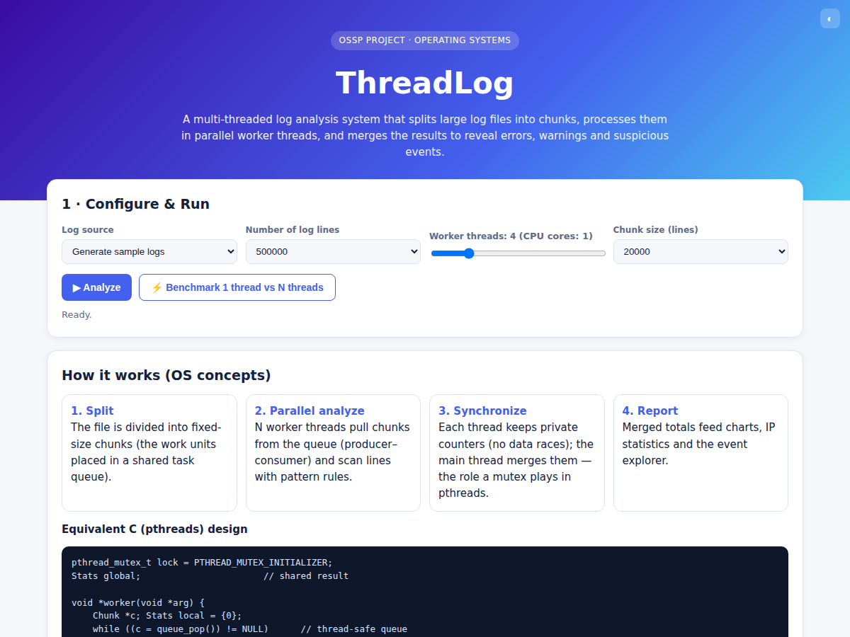
Figure 6.1: Dashboard – start page with the settings
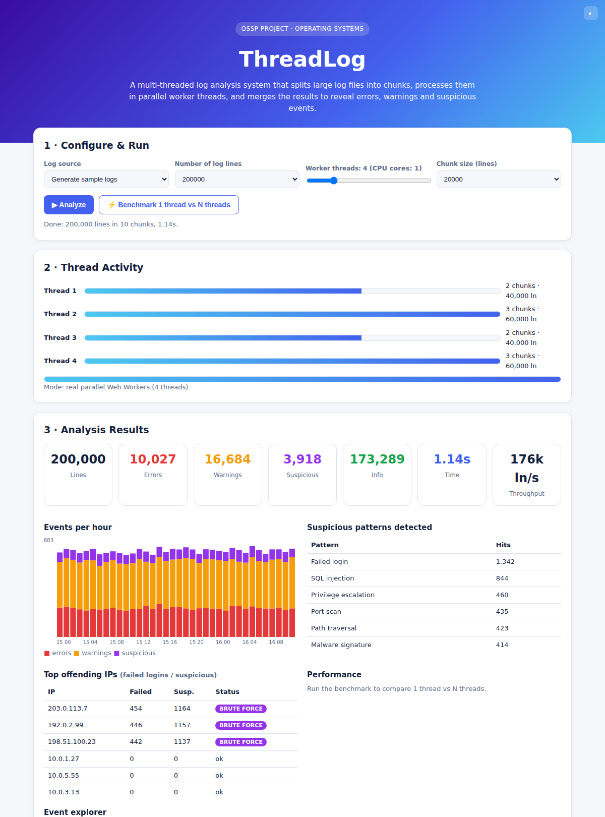
Figure 6.2: Dashboard – thread activity, key figures, suspicious patterns and IP statistics

CHAPTER 7: EXECUTION AND DEMONSTRATION

7.1 Compilation in Ubuntu
Open a terminal in the c folder of the project and compile the analyzer with GCC:
gcc -Wall -Wextra -O2 -pthread -o log_analyzer log_analyzer.c

The program compiles without errors or warnings. (In an earlier version of the source, GCC reported -Wmisleading-indentation for the line that validated the thread count and the chunk size, because two if statements stood on one line; they were put on separate lines.) The -pthread option is required; without it, the linker cannot find the pthread functions on some systems.

7.2 Execution Commands
Generate a test log and run the analyzer:
python3 gen_logs.py 1000000 sample.log # 1,000,000 lines
./log_analyzer sample.log 1 # 1 thread
./log_analyzer sample.log 4 # 4 threads
./log_analyzer sample.log 4 5000 # 4 threads, chunks of 5000 lines

Check for data races with ThreadSanitizer:
gcc -g -O1 -fsanitize=thread -pthread -o la_tsan log_analyzer.c
./la_tsan small.log 4 5000

Measure the run time for several thread counts (median of three runs):
./run_benchmark.sh

Dashboard:
cd web
python3 -m http.server 8000 # then open http://localhost:8000

7.3 Sample Inputs and Outputs
The test input is a generated log of 1,000,000 lines (54,847,797 bytes, about 54.8 MB). The environment was Ubuntu 24.04.4 LTS, Linux 6.18.44, GCC 13.3.0, 1 CPU core and about 4 GB of RAM.
Output of the analyzer with 4 threads (default chunk size of 20000 lines)
Analyzing sample.log with 4 thread(s), 50 chunks
thread 2 processed 12 chunks (240000 lines)
thread 4 processed 12 chunks (240000 lines)
thread 1 processed 13 chunks (260000 lines)
thread 3 processed 13 chunks (260000 lines)

=== REPORT ===
Lines: 1000000
CRITICAL: 8086 ERROR: 41342 WARN: 80264 INFO: 870308
Suspicious lines: 11821
Failed login 1915
Invalid user 1974
SQL injection 1979
Path traversal 1948
Port scan 2026
Malware 1979
Time: 0.440s

Every thread processed 12 or 13 of the 50 chunks. The lines are summed correctly: 8,086 + 41,342 + 80,264 + 870,308 = 1,000,000. The 11,821 suspicious lines (1.18 % of all lines) are, as expected, almost exactly the 1.2 % that the generator writes as suspicious messages. Table 7.1 summarises the results.
Table 7.1: Analysis result for the test log (identical for 1, 2, 4 and 8 threads)
Item | Count | Share of all lines
Total lines | 1,000,000 | 100 %
CRITICAL | 8,086 | 0.81 %
ERROR | 41,342 | 4.13 %
WARN | 80,264 | 8.03 %
INFO | 870,308 | 87.03 %
Suspicious lines (any pattern) | 11,821 | 1.18 %
Failed login | 1,915 | 0.19 %
Invalid user | 1,974 | 0.20 %
SQL injection | 1,979 | 0.20 %
Path traversal | 1,948 | 0.19 %
Port scan | 2,026 | 0.20 %
Malware | 1,979 | 0.20 %

Run time for different numbers of threads
The analysis time was measured three times for each thread count; Table 7.2 and Figure 7.1 show the individual runs and the median. The time covers the thread phase only (from before pthread_create() to after the last pthread_join()).
Table 7.2: Analysis time for 1,000,000 lines (seconds)
Threads | Run 1 | Run 2 | Run 3 | Median | Cores
1 | 0.495 | 0.517 | 0.514 | 0.514 | 1
2 | 0.476 | 0.454 | 0.440 | 0.454 | 1
4 | 0.458 | 0.449 | 0.492 | 0.458 | 1
8 | 0.464 | 0.423 | 0.451 | 0.451 | 1

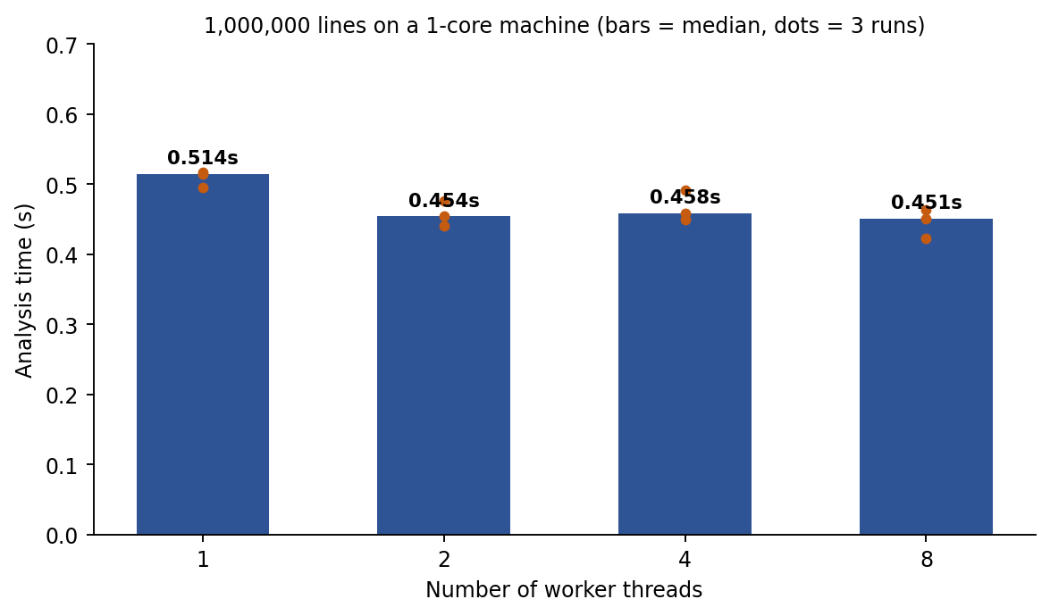
Figure 7.1: Analysis time against the number of threads (1 CPU core)
Important note on these timings. The machine used for the measurements has only 1 CPU core. With one core, the threads cannot run at the same time; the kernel runs them one after another in time slices, so the total work is the same and no speed-up is possible. The time therefore stays at about 0.42–0.52 s, and the differences between the rows are within the normal run-to-run variation of a virtual machine. The table does show one useful thing: the overhead of creating up to 8 threads and of the two mutexes is too small to measure. The speed-up of the parallel design can only be shown on a multi-core computer. Run ./run_benchmark.sh on a multi-core machine (or on WSL2) and replace Table 7.2 and Figure 7.1 with the new results before submission.
On a computer with n cores, the scanning phase should become faster by a factor that approaches n for small n, and then level off, because reading the file, splitting it and printing the report are done by one thread only (Amdahl’s law), and because the number of cores limits the number of threads that can run at the same time. More threads than cores give no further gain.

Effect of the chunk size
The chunk size (third argument) decides how many chunks are in the queue and therefore how often the queue lock is taken. Table 7.3 shows a run with 4 threads for three chunk sizes.
Table 7.3: Effect of the chunk size (4 threads, 1,000,000 lines, 1 core)
Lines per chunk | Chunks in the queue | Time (s) | Result
1,000 | 1000 | 0.439 | Same counts
20,000 | 50 | 0.517 | Same counts
200,000 | 5 | 0.465 | Same counts

The counts were identical in all three runs. Very small chunks mean more lock operations and a larger chunk table; very large chunks make the load balancing coarse (with only 5 chunks, at most 5 threads can have work). A chunk size of some thousand to some ten thousand lines is a good compromise, which is why 20,000 is the default.

Correctness and robustness tests
The four numbers that the analyzer reports for the test log were also obtained with grep, which is independent of the analyzer:
Table 7.4: Cross-check with grep
Quantity | grep command | grep | Analyzer
CRITICAL lines | grep -c '\[CRITICAL\]' | 8,086 | 8,086
ERROR lines | grep -c '\[ERROR\]' | 41,342 | 41,342
WARN lines | grep -c '\[WARN\]' | 80,264 | 80,264
Failed login | grep -ci 'failed password' | 1,915 | 1,915

Table 7.5: Test cases and results
No. | Test case | Expected result | Result
1 | Run with 1, 2, 4 and 8 threads on the same log | Identical counts in every run | Pass
2 | Compare level and “failed password” counts with grep | All four numbers equal | Pass
3 | ThreadSanitizer build, 4 threads, 200,000 lines | No data race reported | Pass (0 warnings)
4 | Empty log file | 0 chunks, all counters 0, no crash | Pass
5 | Last line without a newline at the end of the file | Last line is analysed (2 lines counted) | Pass
6 | Missing file name, or file that does not exist | Message printed, exit status 1 | Pass
7 | More threads (6) than chunks (2) | Surplus threads end without work; counts correct | Pass
8 | Thread count 0 | Replaced by 1 thread | Pass
9 | Chunk sizes 1,000 / 20,000 / 200,000 | Same counts for every chunk size | Pass
10 | Work distribution with 4 threads | Every thread processes 12–13 of 50 chunks | Pass
11 | Compile with -Wall -Wextra -O2 | No warnings | Pass

7.4 Screenshots of Execution
The figures below show the terminal output of the programs. Figure 7.2 shows the compilation, Figure 7.3 the generation of the test log, Figures 7.4 to 7.6 the analysis with 1, 4 and 8 threads, Figure 7.7 the cross-check with grep and Figure 7.8 the ThreadSanitizer run. Figure 7.9 shows the robustness tests.
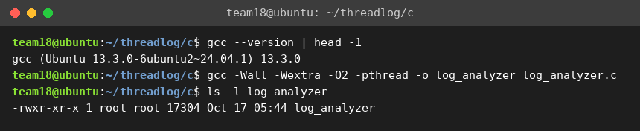
Figure 7.2: Compilation of the analyzer
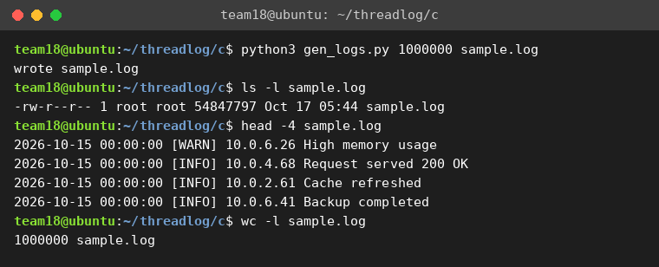
Figure 7.3: Generation of the test log
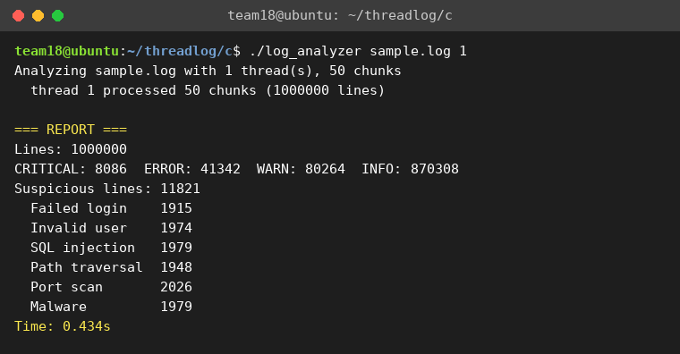
Figure 7.4: Analysis with 1 thread (all 50 chunks in one thread)
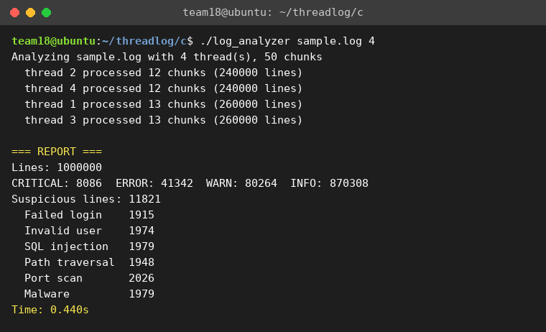
Figure 7.5: Analysis with 4 threads (chunks shared between the threads)
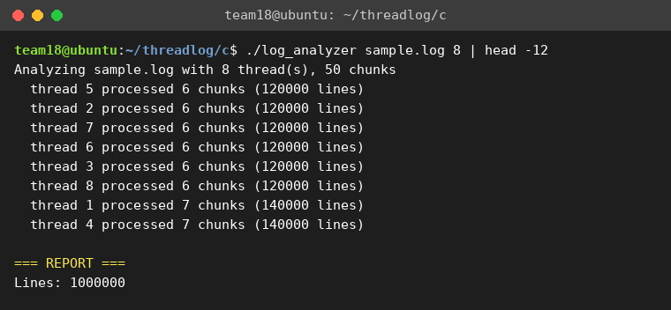
Figure 7.6: Analysis with 8 threads (first lines of the output)
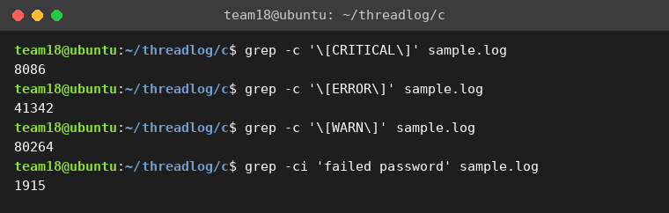
Figure 7.7: Independent counts with grep (compare with Table 7.1)
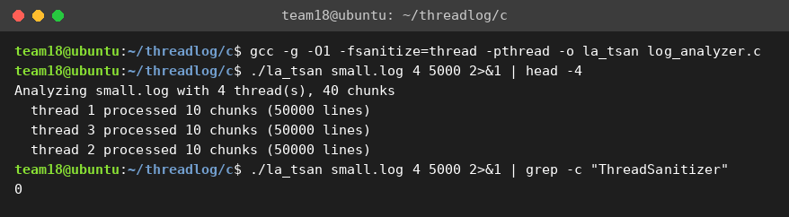
Figure 7.8: Build and run with ThreadSanitizer – 0 warnings
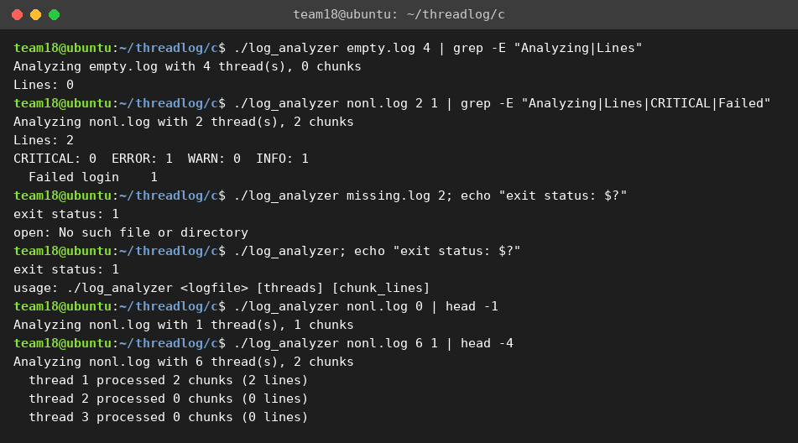
Figure 7.9: Robustness tests: empty file, no final newline, wrong arguments, more threads than chunks

7.5 Demonstration of OS Concepts
Table 7.6 relates the operating-system concepts to what can be observed in the project.
Table 7.6: OS concepts demonstrated
OS concept | How it is demonstrated
Thread creation | pthread_create() starts T workers; each prints its own number and the chunks it processed.
Threads share an address space | All workers read the same buffer and add into the same global structure, with no copying or message passing.
Work division / data parallelism | The file is divided into chunks; the per-thread output shows which share each thread processed.
Dynamic load balancing | The chunk queue gives 12 or 13 chunks to each of 4 threads; a thread that is faster takes more.
Race condition and critical section | global += local and next_chunk++ are the two critical sections; the identical results for all thread counts show that no update was lost.
Mutual exclusion (mutex) | queue_lock and result_lock allow only one thread at a time into each critical section.
Minimising lock contention | Private counters mean a lock is taken per chunk and per thread, not per line.
Race detection | ThreadSanitizer reports no data race in the final program.
Thread join / barrier | pthread_join() makes the main thread wait for all workers before the report.
Scheduling and cores | On one core, the run time does not fall with more threads, which shows that threads only speed up a program when cores are available (Amdahl’s law).
File I/O and memory | The file is read once with fread() into a malloc() buffer that all threads share.

CHAPTER 8: CONCLUSION

8.1 Summary of the Project
This project studied the analysis of large log files with threads and built a working system for it. A multi-threaded analyzer in C with POSIX threads, a test-log generator in Python and a browser dashboard with Web Workers were designed, implemented and tested. The analyzer divides the log into chunks, lets worker threads take the chunks from a shared queue, classifies every line by severity and by six kinds of suspicious events, and merges the private results of the threads into one report under mutex protection. The design uses the OS concepts of threads, work division, race conditions, mutual exclusion and joining, and it was verified with 1,000,000 generated log lines.
Limitations and future scope. The analyzer reads the complete file into memory, uses fixed keyword rules and analyses a file that is already complete. The measurements in this report were made on a single-core machine and therefore do not show the speed-up. Possible extensions are:
- Measuring and reporting the speed-up on a multi-core computer or WSL2, and comparing it with Amdahl’s prediction.
- A true producer–consumer pipeline: a reader thread (or mmap()) feeds chunks into a bounded queue protected by a mutex and condition variables, so that reading and analysing overlap and files larger than the memory can be handled.
- A thread pool that is created once and reused, for real-time monitoring of a growing log (tail -f style) with alerts.
- Configurable rules and regular-expression based pattern detection, and per-IP brute-force detection in the C version (it exists in the dashboard).
- Exporting the report as CSV or JSON and a dashboard that reads the output of the C analyzer.

8.2 Objectives Achieved
Table 8.1: Objectives and their status
No. | Objective | Status | Evidence
1 | Divide a large log file into chunks processed concurrently by multiple threads | Achieved | Sections 5.2 and 6.5; Figures 7.5 and 7.6; Table 7.5 (test 10)
2 | Identify and count ERROR and WARNING entries in each chunk | Achieved | Table 7.1; Table 7.4 (matches grep)
3 | Detect suspicious events using keyword patterns | Achieved | Tables 5.2 and 7.1
4 | Merge thread results safely with mutexes and report a summary with timing | Achieved | Section 6.6; Table 7.5 (tests 1 and 3); Figure 7.8
5 | Show that concurrency reduces analysis time | Design verified; speed-up to be measured on a multi-core machine | Table 7.2 and the note under it; run_benchmark.sh

8.3 Results Achieved
- The analyzer processed 1,000,000 lines (54.8 MB) and reported 8,086 CRITICAL, 41,342 ERROR, 80,264 WARN and 870,308 INFO lines and 11,821 suspicious lines.
- The result was identical for 1, 2, 4 and 8 threads and identical to the independent counts made with grep.
- ThreadSanitizer reported 0 data races for the multi-threaded program.
- The chunk queue distributed the 50 chunks evenly: 12 or 13 chunks for each of 4 threads and 6 or 7 for each of 8 threads.
- The program handled the special cases correctly: empty file, missing final newline, missing or wrong file, more threads than chunks and invalid thread counts.
- On the single-core test machine the run time stayed at about 0.45 s for 1 to 8 threads, showing that the threads and mutexes add no measurable overhead.
- The program compiles with no warnings under -Wall -Wextra -O2, and the dashboard runs the same design in the browser.

8.4 Skills and Learning Outcomes
- Creating, joining and organising threads with POSIX threads, and dividing work between them.
- Understanding race conditions and critical sections, and protecting shared data with mutexes while keeping the locked sections short.
- Designing for low lock contention by using private counters and a chunk queue.
- Checking a concurrent program with ThreadSanitizer and with independent results from grep.
- Understanding the limits of parallel speed-up (cores, serial parts, Amdahl’s law) and measuring a program honestly.
- Compiling, running and testing C programs on Ubuntu with GCC, and preparing a technical report as a team with Git and GitHub.

CHAPTER 9: REFERENCES

9.1 Books
- Michael Kerrisk, The Linux Programming Interface, No Starch Press, 2010.
- Abraham Silberschatz, Peter B. Galvin and Greg Gagne, Operating System Concepts, 10th Edition, Wiley, 2018.
- Andrew S. Tanenbaum and Herbert Bos, Modern Operating Systems, 4th Edition, Pearson, 2014.
- David R. Butenhof, Programming with POSIX Threads, Addison-Wesley, 1997.
- Randal E. Bryant and David R. O’Hallaron, Computer Systems: A Programmer’s Perspective, 3rd Edition, Pearson, 2015.

9.2 Research Papers
- Gene M. Amdahl, “Validity of the single processor approach to achieving large scale computing capabilities,” Proceedings of the AFIPS Spring Joint Computer Conference, pp. 483–485, 1967.
- Edsger W. Dijkstra, “Cooperating sequential processes,” Technical report EWD-123, Technische Hogeschool Eindhoven, 1965.
- Konstantin Serebryany and Timur Iskhodzhanov, “ThreadSanitizer – data race detection in practice,” Workshop on Binary Instrumentation and Applications (WBIA), 2009.

9.3 Linux / GNU Documentation
- Linux manual pages pthreads(7), pthread_create(3), pthread_join(3) and pthread_mutex_lock(3): https://man7.org/linux/man-pages/
- Linux manual page clock_gettime(2): https://man7.org/linux/man-pages/man2/clock_gettime.2.html
- Linux manual page strcasestr(3) (GNU extension): https://man7.org/linux/man-pages/man3/strstr.3.html
- GCC documentation, “Program Instrumentation Options” (-fsanitize=thread): https://gcc.gnu.org/onlinedocs/gcc/Instrumentation-Options.html

9.4 Online Resources
- The Open Group Base Specifications (POSIX.1-2017), pthread_create(): https://pubs.opengroup.org/onlinepubs/9699919799/functions/pthread_create.html
- MDN Web Docs, “Web Workers API”: https://developer.mozilla.org/en-US/docs/Web/API/Web_Workers_API
- Microsoft Learn, “Install WSL”: https://learn.microsoft.com/en-us/windows/wsl/install

